Week 9 – Routing

A pic here…

**Class: PC05**

**Student numbers:**

**Student names: Valentin Vasilev**

Date: Aug 2019  
Version 1.0

# IP Routing

Task 1: A bit more complex network: Part 2

Last week you did the configuration of your IP network for the preconfigured lab.

If you have done well and used either scripts or network/interfaces files, you should be able to restart your configured environment again. Also, you should have a drawing of your network.

Your task is adding routing information to your nodes in such a way, that every node of your network should be able to ping any other node of your network. The routes should be optimal, so the shortest path from node to node should be used. To implement routing, you’ll have to use different types of routes as learned on the theory lesson.

Tip: Use the network drawing from the last week assignment (week 8 ) and first think about the way you’re going to route. Use **tcpdump** and **traceroute** commands to debug your routing.

Provide screenshots of the following pings:

1. PC1A to PC1B
2. PC2B to PC2A
3. PC2A to PC1C

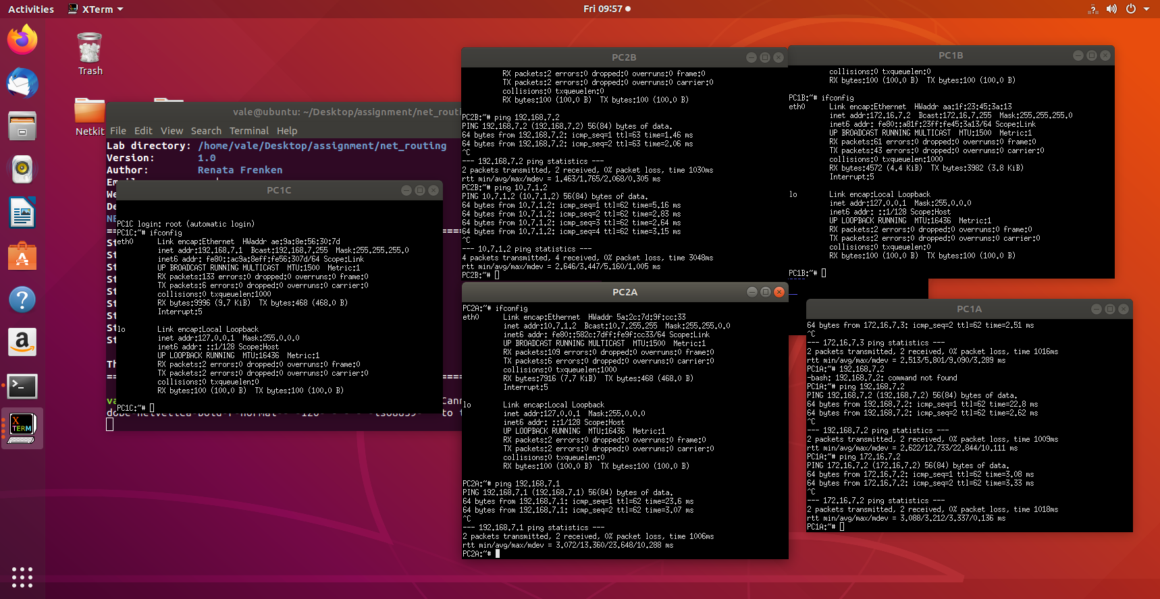

Give a list of all nodes where you had to adjust the routing tables and the screenshots of their configured routing tables.

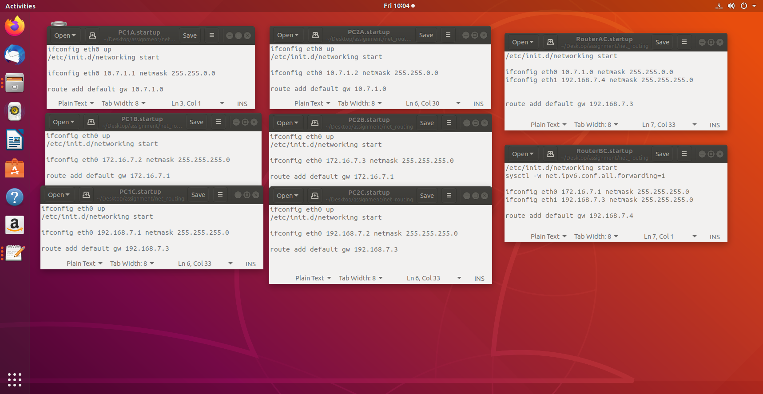

Task 2 (Optional): Access the outside world

The provided lab has also an interface outside of the Netkit to your host Linux machine, so called Netkit tap interface. To use this interface you need to use node Gateway, which is connected with one interface to LANC and with the other (tap) interface to your guest Linux system which is then connected to the outside world. The schematics of this interface is:



Configure your network in such a way that you can reach a node on Internet.

To prove your correct configuration you should be able to ping a host like 8.8.8.8 (Google DNS server) from any node on your network.

Provide screenshots of the following ping:

PC1A to 8.8.8.8, PC1B to 8.8.8.8

Table 1 : IPv4 address ranges per pair

|  |  |  |  |
| --- | --- | --- | --- |
| Pair | LANA | LANB | LANC |
| 1 | 10.1.0.0/16 | 172.16.1.0/24 | 192.168.1.0/24 |
| 2 | 10.2.0.0/16 | 172.16.2.0/24 | 192.168.2.0/24 |
| 3 | 10.3.0.0/16 | 172.16.3.0/24 | 192.168.3.0/24 |
| 4 | 10.4.0.0/16 | 172.16.4.0/24 | 192.168.4.0/24 |
| 5 | 10.5.0.0/16 | 172.16.5.0/24 | 192.168.5.0/24 |
| 6 | 10.6.0.0/16 | 172.16.6.0/24 | 192.168.6.0/24 |
| 7 - mine | 10.7.0.0/16 | 172.16.7.0/24 | 192.168.7.0/24 |
| 8 | 10.8.0.0/16 | 172.16.8.0/24 | 192.168.8.0/24 |
| 9 | 10.9.0.0/16 | 172.16.9.0/24 | 192.168.9.0/24 |
| 10 | 10.10.0.0/16 | 172.16.10.0/24 | 192.168.10.0/24 |
| 11 | 10.11.0.0/16 | 172.16.11.0/24 | 192.168.11.0/24 |
| 12 | 10.12.0.0/16 | 172.16.12.0/24 | 192.168.12.0/24 |
| 13 | 10.13.0.0/16 | 172.16.13.0/24 | 192.168.13.0/24 |
| 14 | 10.14.0.0/16 | 172.16.14.0/24 | 192.168.14.0/24 |
| 15 | 10.15.0.0/16 | 172.16.15.0/24 | 192.168.15.0/24 |